Cover Image: Pocket park in CMCL parking lot designed by Mary Lou Weaver Houser and constructed by Scott Weaver and Dave Lutz. Chairs anchored by Wayne Martin. If you have not seen it, check it out.
Calendar:
June
20–22 Peace School, 6–8 p.m.
24 Prem Dick Memorial Service, 1:30 p.m.
24 Church Cleaning, 8:30 a.m.–noon.

CHURCH INFORMATION

Contact the church office staff at (717) 392-7567 or cmcl@communitymennonite.org.

Worship service: 9:30 a.m.

Bulletin Announcements: bulletin@communitymennonite.org by 4 p.m., Tuesday

Midweek Announcements: bulletin@communitymennonite.org by 4 p.m., Tuesday

Lead Pastor: Susan Gascho-Cooke––(susan@communitymennonite.org), 717-224-6863, (Monday, Tuesday, Thursday and Friday, 9 a.m.–5 p.m. Wednesdays off)

Associate Pastors of Children & Youth:

Amanda Stoltzfus (Amanda@communitymennonite.org), Tue and Thu—10-3;

Malinda Clatterbuck (Malinda@communitymennonite.org), Mon and Thu—8:15-5

Pastoral Team: Verna Miller, Carol Spicher, Deb Napolitan and Luke Good

Office staff: Rod Houser (Tues, Thurs), Rachel Kraybill Stahl (Mon, Wed, Fri)

Small groups: Church office.
Childcare Coordinators: Kandace Helmuth (Kandace@ptd.net), Michelle Meck (meckmp@aol.com)
To join our closed Facebook Page, search for Parrot Nation and request to join.

Community Mennonite Church of Lancaster
328 West Orange Street, Lancaster, PA 17603
June 18, 2017

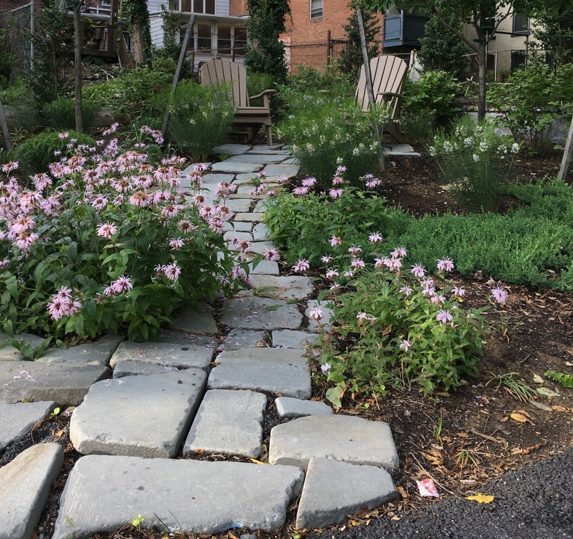

What/Where is this place?
(If you’re not sure, check the back page)

Prelude Daryl Snider
Lighting of the Peace Lamp
Welcome/Call to Worship
Gathering Hymns What is this place HWB #1
Christ is our cornerstone HWB #43
Scripture Matthew 3: 16–17
And when Jesus had been baptized, just as he came up from the water, suddenly the heavens were opened to him and he saw the Spirit of God descending like a dove and alighting on him. And a voice from heaven said, ‘This is my Son, the Beloved, with whom I am well pleased.’
Children's Time Diane Umble
We value children's participation in worship.
This is a sacred time for children and adults alike.
Let us listen and see with the eyes and ears of a child.
Offering/Offertory Daryl Snider
Welcoming New Members—Larry and Sherry Groff
God of community,
whose call is more insistent
than ties of family or blood;
may we so respect and love
those whose lives are linked with ours
that we fail not in loyalty to you,
but make choices according to your will.
We give thanks for the life and faith of each new member today.
Grant that they may be drawn into the life of the congregation,
sharing their gifts and receiving from the gifts of others,
may the fullness of your Spirit dwell in them and overflow into your world.
Amen
Hymn I will stand in the congregation STS #113
Sermon Susan Gascho Cooke
Sharing Time and Prayer
Where do you sense God moving among us? This is a time to respond to the scripture, music and message of the morning, and to share joys and concerns from your lives and the greater world.
Announcements/Introduction of Visitors
Sending Hymn Lord I am fondly earnestly longing HWB #514
Benediction
Worship Leader––Jay Martin
Prelude/Offertory—Daryl Snider
Song Leader—Ron Umble
Sound Technicians—Monte Garber
Environment—Carmalena Stoltzfus Iyengar, Beky Weidner
Greeter—Diane Umble
Ushers—Linda Berger, Jim Spicher
Child Care
Worship Service—Christine Kaufman, Kandace Helmuth
Helper—Maia Shenk

